**Special UNICODE characters**

Some Unicode characters cannot be represented directly in a Java string since it uses only 16 bits per character. But there is an escaping mechanism called "**surrogate pairs**".

Ex. the character number **1f50a** for example can be represented by the two 16 bit 'characters' : 1f50a => D83D and DD0A

Something like "\uD83D\uDD0A".

It still depends if this character is available in the used font.

Link: <http://www.russellcottrell.com/greek/utilities/SurrogatePairCalculator.htm>

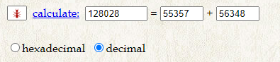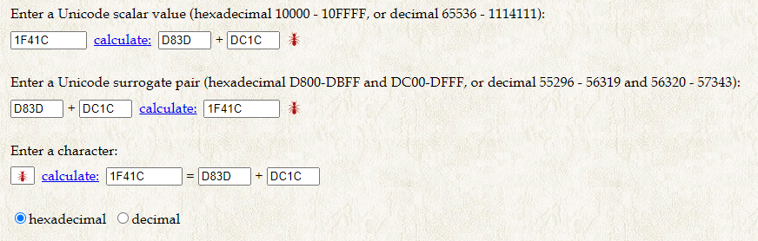

"\uD83D\uDC1C"



Link: <https://charbase.com/1f41c-unicode-ant>

|  |  |
| --- | --- |
| **Your Browser** | 🐜 |
| **Index** | U+1F41C (128028) |
| **Class** | Other Symbol (So) |
| **Block** | [Miscellaneous Symbols And Pictographs](https://charbase.com/block/miscellaneous-symbols-and-pictographs) |
| **Java Escape** | "\ud83d\udc1c" |
| **Javascript Escape** | "\ud83d\udc1c" |
| **Python Escape** | u'\U0001f41c' |
| [**HTML Escapes**](https://charbase.com/html-entities) | &#128028; &#x1f41c; |
| **URL Encoded** | q=%F0%9F%90%9C |
| **UTF8** | f0 9f 90 9c |
| **UTF16** | d83d dc1c |

Link: <https://www.babelstone.co.uk/Software/BabelMap.html>

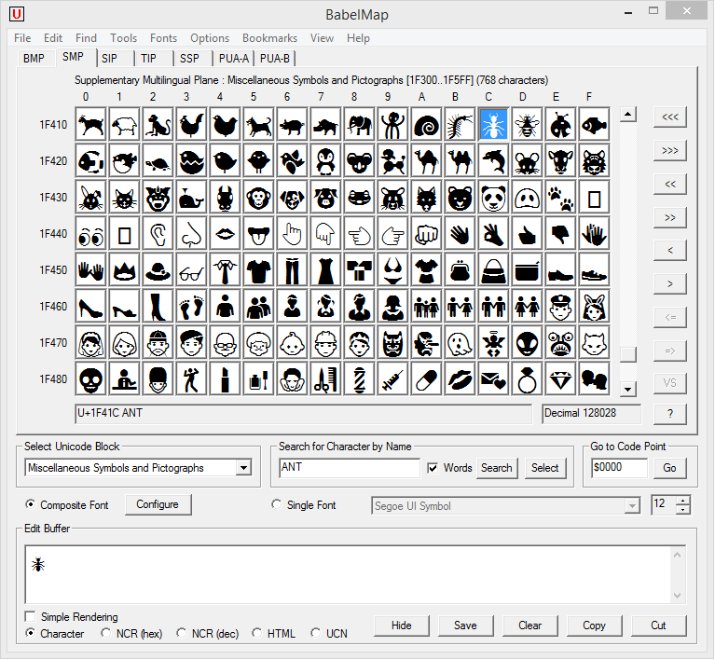

Link: <https://unicode.org/emoji/charts/full-emoji-list.html>